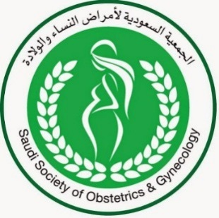
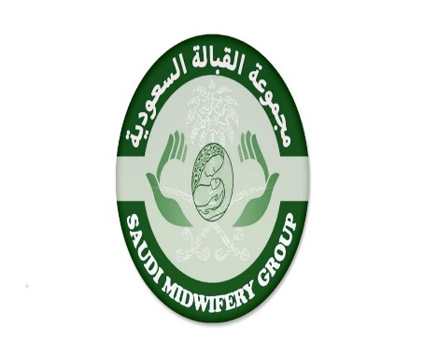
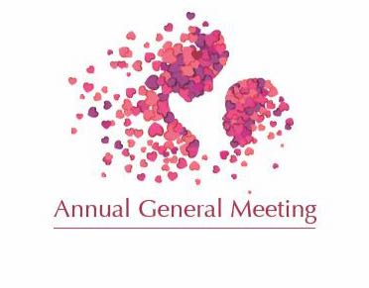

4th Annual General Meeting
November 24th, 2019

The Annual General Meeting of the Saudi Midwifery Group (SMG) is conducted in the fourth quarter in which the group review the activities and achievements. In addition, it is considered the biggest event for midwives; Saudis and expatriates at equal level to meet and exchange the experiences of the midwives from different parts of the world. It is also an opportunity to share the recent evidence-based knowledge about the new practices in the Midwifery field. However, the plan for the upcoming year is to apply for more CME hours for the scientific papers and presentations by the midwives from different parts of the kingdom. Furthermore, SMG usually shares its achievements with the healthcare providers as well as public and open the stage for the interaction between the board members and the community through electing their new members. This year, SMG will be unique as we will share experience from external candidates (mainly from the GCC and some Arab countries).
Note: that the updated SMG Constitutions and Bylaws will be shared with the Audience.
Submission deadline: September, 30th.
Guidelines for Abstract Submission
- Abstracts are invited for oral or poster presentation.
- Abstract may only be submitted using the template on the SMG web page.
- Abstracts must be clear and demonstrate clarity in purpose of the presentation and benefits to conference participants.
- Presentations arising from a research project must have agreement for the research to be presented. The scientific committee is not responsible and/or will not communicate/participate in any discussions relating to disagreement of authorship and/or the right to present a paper.
- Suitable abstracts which cannot be accommodated as an oral presentation, may be presented as a poster
- Abstracts will only be accepted if submitted in the attached template
- Abstracts must be sent as soft copies to Taghreed Hawsawi at tmhawsawi_5@hotmail.com or taghreed.hawsawi@gmail.com by September 30th
- Presenters will be notified whether their abstract has been accepted immediately.
- Please submit copy of CV and midwifery license and the personal biographic info.
- Oral presentations will be maximum 20 minutes in length.
***An email confirming receipt of your abstract will be sent to you within two (2) working days. If confirmation is not received within this time period, please contact
Taghreed Hawsawi:
Mobile: 0552100220 Email: tmhawsawi_5@hotmail.com or taghreed.hawsawi@gmail.com

Presenter detail PRESENTERS

PRESENTER:
Full Name:
 | Last |  |  | First | Middle |  | Title

Contact details for Primary Presenter

ALL COMMUNICATION WILL BE WITH THE SUBMITTING AUTHOR, REFERRED TO AS PRIMARY PRESENTER

Address:
Riyadh
 | City | State /Country | /Zip Code

MOBILE: |  | Email
With area code

If employed in Saudi Arabia

SCFHS: |  | SCFHS:
Registration Number Expiry Date

Please attach copy of Saudi Council for confirmation

ABSTRACT (no more than 300 words)

Primary Presenter
Theme

Title
Introduction

Aim
Methods (if research) OR
Main discussion points (if non-research topic)
Results/
Outcomes
.

Conclusion
Implications for Midwifery in SA

Please make your selection
Poster☐ Oral presentation☐

